FRIENDS AND FAMILY TEST
Results for October 2024

Thank you to all the patients who completed a friends and family test survey in October 2024.

- How likely are you to recommend our practice to family and friends if they needed similar care or treatment?
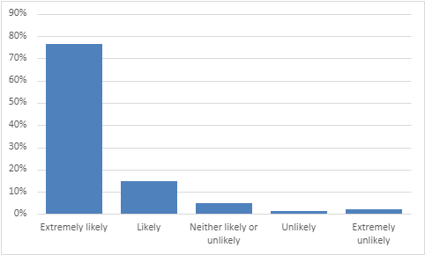

76% are extremely likely to recommend the practice
15% are likely to recommend the practice
5% are neither likely nor unlikely to recommend the practice
1% are unlikely to recommend the practice
10% are extremely unlikely to recommend the practice

- If we could change one thing about your care or treatment, what would it be?
- I’ve always been happy with the treatment I have received at Coppull Medical Practice. They are very caring and extremely helpful.
- My treatment was perfect as usual – the best treatment and care anybody could wish for.
- The care and treatment from you all are brilliant. The staff are excellent – all so kind and caring. Full marks to you all.
- Everything was excellent from Dr Harris.
- Dr Hart was such a lovely and informative GP.
- Dr Craghill was most helpful, attentive and informative.
- Dr Hart is an absolute credit to your surgery. She is extremely kind, friendly and professional, one of the best GPs I have ever seen.
- Dr Brown, as always, put me at ease and treated me very well.
- Always excellent care and compassion – Dr Rawson especially.
- Nurses are brilliant.
- Dr Hart is a fantastic doctor; she is genuine and has a lovely aura.
- Dr Hart is a great asset to the practice; she listens and has empathy and is so understanding.
- My hat goes off to Dr Hart. Inspirational and so caring. Can’t say enough lovely things about her. Thank you so much.
- Dr Harris has been so lovely and helpful.
- Dr Harris was lovely, very thorough.
- Great experience with Dr Rawson.
- Dr Rawson gives excellent compassion and care.
- Dr Brown listened to my concerns, gave succinct advice and organised further follow up. He was easy to talk to.
- Dr Brown has been my doctor for 40 years. Great service looks after our family. Top service.
- The nurse practitioner I saw is a delightful person, so caring and lovely to speak to.
- My daughter’s appointment was dealt with promptly, the nurse was amazing.
- Justine was absolutely lovely. She listened to me and more importantly, understood me, so thank you.
- I have felt fully supported and the care I have received has been outstanding. No improvement required, thank you to Justine.
- Tracey is fantastic, friendly, professional and reassuring.
- Very friendly, professional and helpful appointment with Tracey
- The physio was very thorough and answered all my queries. Good experience.
- The physio first contact practitioner was kind, engaging and gave me appropriate advice and encouragement.
- The prescription lady is brilliant at sorting things.
- The receptionist, practice nurse and physio were very polite and understanding.
- The reception staff are always kind and helpful.
- The doctor was really helpful and explained the procedure to me with great care, and the treatment I received was excellent.
- I was made to feel relaxed and put at ease. All staff, reception, nurses and clinicians showed empathy and a willingness to help.
- The care I have received from the surgery for my two children has been exceptional from reception staff to nurses and doctors. You have all been incredible. Thank you so much.
- Make the triage form more ‘visible’ and easily accessed on the app/website.
- Make the website more intuitive.
- Be able to submit a request at all times of day even if they are only sorted at a certain time.
- More face-to-face appointments and being able to get appointments sooner.
- Call back service didn’t work when I requested it.
- The wait for blood test appointments is too long.

